**NFCSD Art Educators**

**PREK 3 & 4**

***Open-ended art with toilet tissue rolls***

Save a few of those precious spent toilet tissue rolls and give your little ones an opportunity to create some fun characters.

Animals, people-family members, self-portraits, made-up creatures, machines/vehicles, instruments or toys

Set up an area where creativity can take place. A covered area on the floor in a quiet area or on your kitchen or dining room table. Access to the rolls, tape, glue, different kinds of paper or scraps, ribbon sticky notes, old mail, bottle caps, etc..

The following are examples. **Parents** please guide your child through a selection process or ask what they would like to create. Have fun and please share your creations by email with your art teachers and they will be sure to respond!

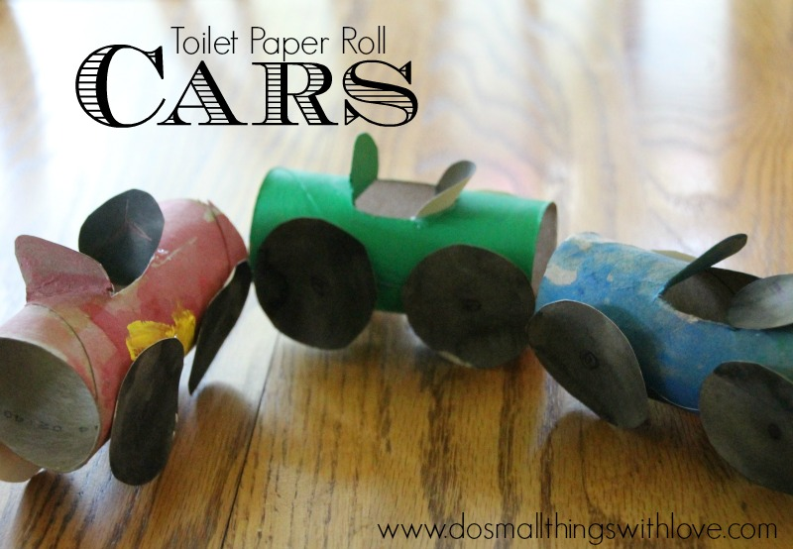

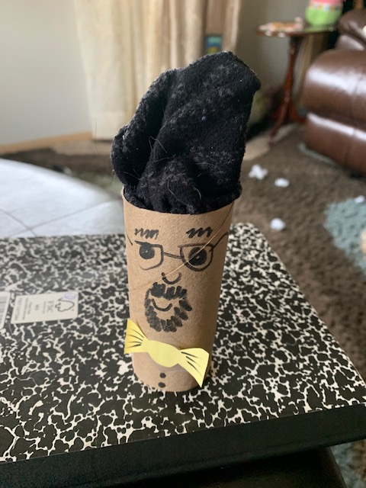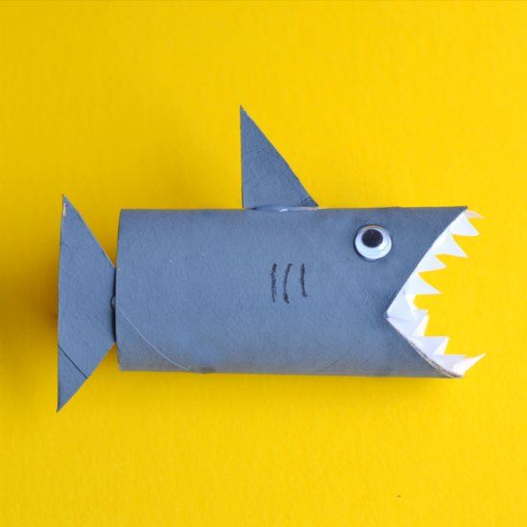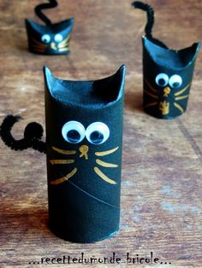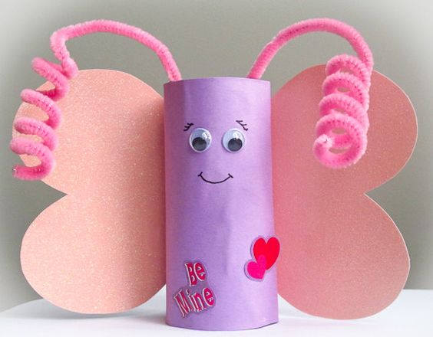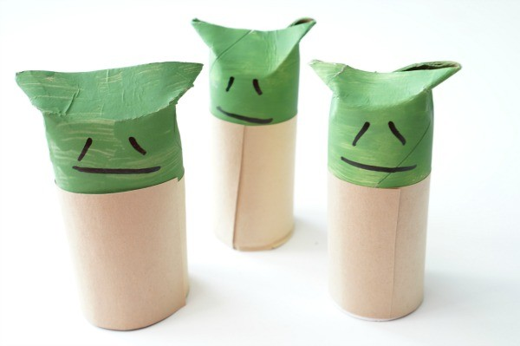

Pinterest page for more ideas… <https://catholicsprouts.com/51-toilet-paper-roll-crafts-2/>

